**Overview of "Design of a Series Elastic Transmission for hand exoskeletons"**

**Research Motivation:**

The research work on this paper is motivated by the increasing demand for innovative rehabilitation solutions, particularly for individuals with hand disabilities. With the global rise in aging populations and the prevalence of neurological and musculoskeletal conditions, there is a growing need for wearable robotic devices that can provide intensive and effective therapy while reducing the burden on healthcare professionals. The specific focus on hand exoskeleton systems stems from the challenges associated with motor and sensor requirements, mechanism design, weight, size, and dexterity, which have hindered the development of portable hand exoskeletons compared to other wearable robotics for lower and upper limbs.

**Innovation Points:**

One of the key innovation points of this paper lies in the development of a novel Series Elastic Transmission (SET) for the Hand Exoskeleton System (HES) . By incorporating a Series Elastic Actuator (SEA) and utilizing topology optimization techniques, the design of the SET aims to provide accurate force measurement using angular sensors and introduce compliance for safety and comfort during use. This innovative approach not only addresses the challenges of matching maximum bearable deformation and specific stiffness within limited space but also enhances the portability and functionality of the hand exoskeleton system.

**Design Methods:**

The design process of the Series Elastic Transmission involves a detailed analysis of the kinematics and kineto-statics of the finger mechanism within the exoskeleton system. By characterizing the torque requirements at the actuated joints and optimizing the design based on innovative topology optimization techniques, the research team ensures that the elastic component of the SET meets the desired specifications. The redesign of the HES structure for manufacturing in titanium alloy and the application of the SET to other mechanisms for different human joints with limited accessibility further demonstrate the versatility and adaptability of the design methods employed.

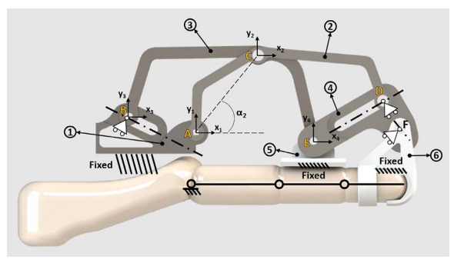

**Fig. 4.** The 1 DOF mechanism of one finger of the exoskeleton. Black circled numbers indicate the part of the mechanism, yellow capital letters mark each joint. (For interpretation of the references to color in this figure legend, the reader is referred to the web version of this article.)

**Experimental Setup and Analysis:**

The experimental validation of the SET plays a crucial role in confirming the effectiveness and reliability of the design procedure. Mechanical tests are conducted to evaluate the performance of the elastic component and ensure that it meets the required features. The results of these tests provide valuable insights into the functionality and usability of the Series Elastic Transmission within the Hand Exoskeleton System, validating the optimization-based design approach and highlighting the benefits of incorporating compliance and accurate force measurement capabilities.

**Conclusion and Limitations:**

The research on the Series Elastic Transmission for hand exoskeletons represents a significant advancement in the field of wearable robotics for rehabilitation and assistance. The integration of innovative design methods, topology optimization techniques, and experimental validation processes contributes to the development of effective and safe solutions for individuals with hand disabilities. However, it is important to acknowledge the limitations of the study, such as the need for further clinical testing and validation in real-world scenarios to fully assess the practical implications and benefits of the proposed SET design. Despite these limitations, the research sets a solid foundation for future advancements in hand exoskeleton technologies and opens new possibilities for enhancing rehabilitation therapy and daily task assistance for individuals with hand disabilities.